Starting Martlesham Preschool
Prospectus
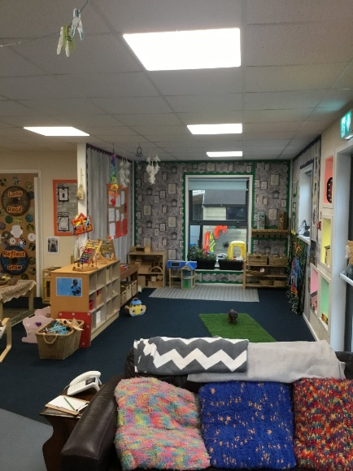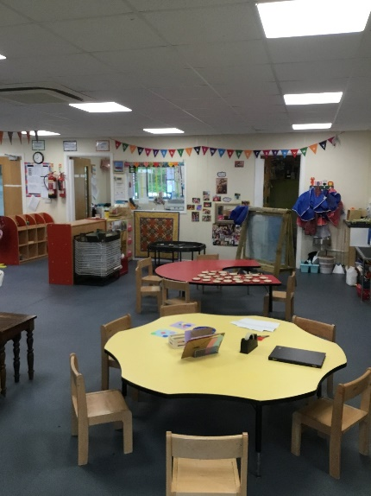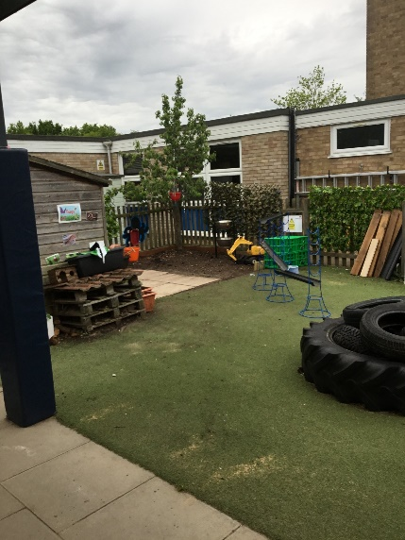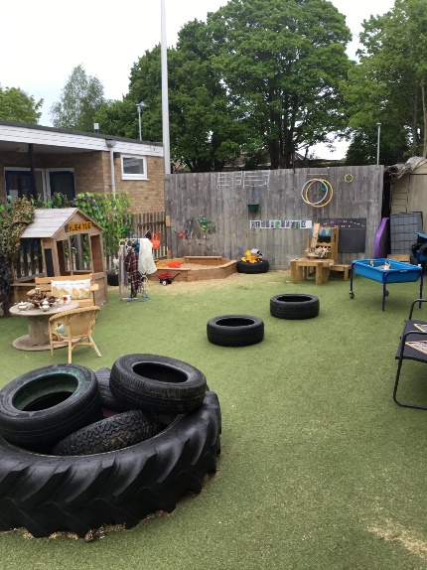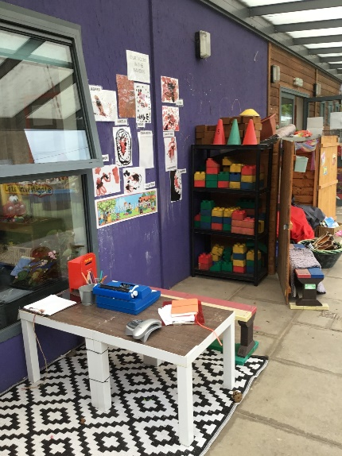

“Children delight in exploring the inviting spaces and high-quality toys. They confidently work together to develop their own games and imaginative ideas”
OFSTED June 2019

We would like to welcome you to Martlesham Preschool and hope that you, and your child will enjoy your time with us. Here are some notes for you to read through before your child starts which will hopefully answer any questions you have. However please always feel free to contact us on the above details with any issues or further questions.
A committee of parents is elected each year at an Annual General Meeting (AGM) to run the Preschool. Every parent who has a child at Preschool is eligible and very welcome to attend the AGM and vote. The committee employs a Setting Manager, Administrator and Early Years Practitioners and is also responsible for policy making.

We have a strong, well qualified team with a great deal of experience. They not only continue to undertake a high level of Child Care qualifications but are all fully qualified in Paediatric First Aid, Safeguarding Children and Food Hygiene. They have many years of experience between them so please feel free to ask for help or advice at any time, from potty training to fussy eaters they are sure to have experienced it all before and are always happy to help.

“The progress of individual children is closely tracked. Staff swiftly identify any gaps and provide tailored support to help children to catch up and continue to move forward in their learning and development.” OFSTED June 2019.

Our setting manager, designated Safeguarding Lead, and setting deputy SENCo is Nicola Cobb who is contactable via Telephone or email.
We have many policies which provide the framework of the everyday running of the Preschool, these can be accessed for your information on our website, or a copy obtained via the office.

Home Visits and trial sessions.
- We can offer a home visit should we feel this will be beneficial in helping your child transition into preschool.
- We offer two trial sessions, free of charge, before your child officially starts with us at Martlesham Preschool. The sessions are scheduled for an hour each. You can stay with your child or you can leave them for the hour, this is totally up to you.

Preschool Setup
We promote a free-flow play and learning environment, making good use of both our indoor and outdoor space. We are also very fortunate to have a lovely woodland and other local amenities within walking distance and will often take the children out on short outings.
We accept children from 2 years until school age and open term time only. The children all use the same space and this works so well as the children can teach each other so much, including but not limited to compassion and resilience. Term dates can be found on our website.
We offer opening times between 8am and 4pm. Our morning session runs 9am-12pm and our afternoon session runs 12pm-3pm. We also offer lunch club (12pm-1pm) if you wanted to extend the morning session. We also offer the wraparound hours too, offering add-ons of an hour or half hour at either end of the day. We accept 2,3 and 4 year old funding and this funding can be used across any of our opening hour sessions.

The First Early Days
- Every child is individual and so communication between you and the staff in the setting is vital. It may be important for both you and the child to spend the first few sessions together, however spending a shorter time in the session apart from you may also be more beneficial.
- When you feel that your child is ready to stay on their own for all or part of a session, a quick good-bye is best. Please don’t slip out without telling them and us that you are going, and when you will be back.
- Your child will be happier when he/she has had time to get to know their way around, knows where the toilet is, and knows the names of the staff, and some of the children.
- Every child will have a Key-Person, this will be a member of staff who your child will meet during their time at Preschool and has special responsibilities for giving the child the re-assurance to feel safe. It is also the responsibility of the Key-Person to liaise with you to keep up to date your child’s Learning Journey. The information in the registration form is a great starting block for this.
“Good emphasis is placed on supporting children to form close bonds with their key person. Staff meet with parents and gather detailed information about children's previous experiences, likes, dislikes and specific needs. They use this information effectively to help children to develop strong levels of emotional well-being, particularly when they first attend and when they experience unsettled times at home” OFSTED June 2019

Toilets
- There are 3 children’s toilets and a separate adult/disabled toilet available.
- Nappy changing facilities are available, and we request you bring your own nappies and wipes.
- Spare clothes should be provided in your child’s bag. We do have some spare clothes available at Preschool to cope with any accidents. If your child uses any of these, please launder them and return as soon as possible.
- Whether you are helping out or staying with your child during their first few sessions, please note that because of Child Protection regulations only vetted staff are allowed in the toilets with the children, and we must adhere to the Mobile Phone Policy, which does not allow mobile phones in the playroom.
Food, drink and resources.
Please provide your child with a named water bottle on every session. If your child is staying for lunch, please provide a healthy packed lunch but please remember we are a NUT FREE preschool.
If your child is doing breakfast or late stay club, Martlesham Preschool can provide breakfast and a snack at late stay.
Fresh Milk will be available on every session.
In order to avoid the need to charge for consumables, we do rely on voluntary contributions to our snack and resources each half term. To avoid wastage, we would appreciate the perishable goods over the course of the half term; therefore, we will email out to parents (in groups), throughout the course, to ask if you are able to make any donations of perishable goods at that specific time. We welcome non-perishable items at any point, if you feel able to donate.

Contact Details
- If parents/carers are not picking up their child, please notify us of any changes.
- Please remember to inform the Manager or Administrator of any change to contact telephone number(s) or address immediately.
Learning through Play
- Martlesham Preschool follows the Early Years Foundation Stage, which is well established within the setting.
- By providing well-planned experiences based on children’s spontaneous play; both indoors and outdoors, all the staff will support the children to learn with enjoyment and challenge.
- Through play, in a secure but challenging environment with effective adult support, children can explore, develop, and represent learning experiences that help them make sense of the world. They can practise and build up ideas, concepts and skills, and they will learn how to understand the need for rules.
- It is through play that the children will develop their personal, social and emotional development, as well as their physical, communication, language, literacy, mathematics, understanding of the world and expressive arts and design skills.
“Children show high levels involvement in practical tasks, such as measuring, mixing and kneading ingredients to make play dough. Staff express an interest in the children's dough models and demonstrate new ways for children to manipulate the dough using their hands and other tools. This helps to strengthen children's physical dexterity in preparation for writing.” OFSTED June 2019

Promoting a healthy lifestyle

Martlesham Preschool strongly encourages adults and children to have a healthy lifestyle wherever possible. We need to encourage all our users (staff; parents and children; and visitors) to walk, scooter or cycle wherever possible. Building exercise into your day is all-important, especially for children. Even leaving the car at home and walking half an hour a day is going to benefit them greatly and prepare them well for adulthood. Walking helps burn calories. Experts advise that children and young people should achieve a total at least 60 minutes of at least moderate intensity physical activity each day. Walking or cycling to school can make an important contribution to this. Walking their children to school allows parents to spend more quality time with their children without the distraction of having to drive. They can help them learn about their local environment and develop crucial road safety skills. Walking regularly enables a child to become more familiar with their surroundings and provides them with the opportunity to learn about the weather and changing seasons first hand.

“Staff encourage children to learn about the benefits of being active and eating healthy foods.” OFSTED June 2019

Cycle Racks and Buggy Store. Cycle racks and a buggy store are situated next to the entrance. You are welcome to leave bikes and pushchairs in the store whilst your child is at preschool, these are left at your own risk.

For the safety of you and your child, please do not use the school car park entrance when walking. Walk a little further along the footpath and use our pedestrian entrance.

There is STRICTLY NO PARKING in the school car park. If you park in the roads in the surrounding area we would kindly ask you to park considerately and safety. Also, please bear in mind that the yellow lines near the school entrance are enforced at certain times. Please do not park in the turning area opposite the school gates in Deben Avenue.

Preschool/Playschool/Nursery/Kindergarten …. What’s the difference?
So, you finally have your child settled into the perfect setting. They make wonderful friendships, it’s close to home and work and you feel confident that they are happy. The situation couldn’t be any better.
But then you start to hear other parents talking about nursery/preschools/school etc and your mind starts to turn to primary school! Now you have questions and a whole new dilemma!
What is school nursery? Does my child have to move? How are preschools, nurseries, playschools, kindergartens different? What do I need to do to make sure my child has the best start in school?
There is so much confusion around the names of settings and where your child should go however there is little difference at all.

Most children will begin school the September after their 4th birthday. When your child turns 3 you may be starting to look into local primary schools and making your application. Many primary schools also offer school nurseries for children age 3-4, and you may consider moving your child there before you make your school application. But is this right for your child? Let’s explore a few options.
All Early Years settings follow the same Early Years Foundation Stage guidelines which impacts on the learning, development and care of children from birth to five years.
At Martlesham Preschool we base our sessions around the children’s interests and needs, every child is individually planned for and staff observe children and offer educational activities that help children to progress and succeed. We do not follow topic-led teaching as we feel this does not follow the principles of the EYFS framework which puts a heavy emphasises on following the lead of the child which in turn makes learning much more enjoyable and achievable.
At Martlesham Preschool we offer 8am-4pm Monday to Friday term time sessions which can ALL be used within your government funding.
We work closely with all schools within the area to ensure their transition goes as smooth as possible when it comes to going to school. Class teachers come to our setting to meet and greet the children, often bringing a wonderful activity and we go to the school with the children also.
There is often anxiety around will my child have any friend’s going to school if they stay at a preschool, nursery or kindergarten that is not part of the school? Children are naturally friendly and curious – they will approach their peers and make friends with ease, sometimes taking time but it does happen. Children build confidence in a place they feel safe and secure and by the time it gets to school they often feel confident and secure enough with the support from staff and the transition process to settle with ease.
Please also bare in mind the schools do not make a decision about who is accepted into the reception year – the decision is made by the local authority on a criteria basis. Just because your child attends a school nursery does not guarantee them a place in the school.

Questions to ask when deciding between settings:
- What is the staff to children ratio?
- Will my child get help going to the toilet if needed?
- What if a child has a toileting accident? Who will help them? How many staff will be left with the other children during that time?
- What early years qualifications and training do the staff have?
- Are all staff first aid trained?
- Does the setting have a suitable environment, resources and equipment for all children?

If your child is settled and happy within their setting, then keep supporting that! Children build wonderful relationships with staff and peers around them which impacts on their personal, social and emotional development, impacting on great transitions into school. They will receive good education and care with qualified and well experienced members of staff at Martlesham Preschool.

If you have any problems, questions or queries at any time please speak with us, we pride ourselves on being approachable and will always do our very best to help wherever we can.

